Joint Grant Awards program (JGAP)
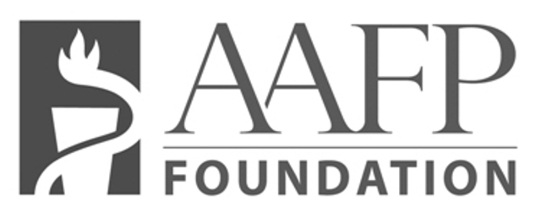

Application

- Study Title

Contact information for the principal investigator and each co-investigator (Refer to instructions)
- Total Amount of Grant Funds Being Requested, the Total Cost of the Proposed Project, and the Percent (%) of the Total Project Cost the AAFP Foundation Amount Represents
- Proposed Length of Project Including the Anticipated Beginning and Completion Date.
- Name of Applicant Organization/Institution.
- Name of Authorized Official, Title, Office Address and Phone Number
- Hypothesis (limited to 120 words)
- Abstract (limited to 250 words)
- Background, Methods and Data Analysis Section (limited to 5 pages)
- Background
- Methods and Design
- Analysis of Data
- References for Background, Methods, and Analysis Section
- Budget
 | AAFP Request | In-kind | Other Grant Funds | Total
Salary and Wages
Payroll Taxes & Fringe Benefits
Consultants
Travel
Computer Support
Communications
Supplies and Materials
Equipment
Other Direct Expenses
GRAND TOTAL

- Budget Justification
- IRB Approval and Informed Consent
- List of Appendices
- Biographical Sketch(es)
Provide for each investigator listed on page one the following information beginning with the Principal Investigator.

Name |  | Position Title
Education
(Begin with baccalaureate or other initial professional education, and include postdoctoral training.)
Institution and Location | Degree |  | Year  Conferred | Field of Study
Research and Professional Experience
(Concluding with present position, list, in chronological order, previous employment, experience, and honors. List in chronological order the titles and complete references to all publications during the past three years and to representative earlier publications pertinent to this application. (Do Not Exceed Two Pages.)
- Special Section for Applications Resubmitted for Consideration
Resubmission: Yes No (double Click on Yes/No response)
If yes, provide a brief summary of how the cited deficiencies in the original application have been addressed.

Applicant Agreement
In the event a grant is awarded to support this application, the applicant and applicant organization/institution agree to adhere to all award conditions specified by the AAFP Foundation as outlined in the instructions available at www.aafpfoundation.org/research.

Typed Name and Signature of Principal Investigator Date

Typed Name and Signature of Authorized Official Date

Please indicate below how you FIRST learned about the AAFP Foundation’s research grant programs.

AAFP Foundation’s Website (www.aafpfoundation.org)
AAFP’s website (www.aafp.org)
AAFP Annual Scientific Assembly
North American Primary Care Research Group (NAPCRG)
National Conference of Family Medicine Residents and Students
Residency director
Faculty
Colleague
Other

Application Questions?
www.aafpfoundation.org/Research

