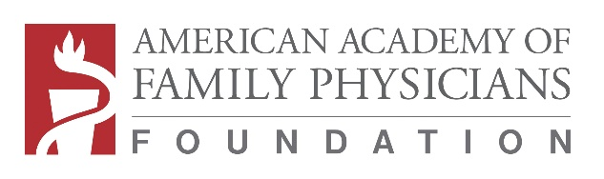
Student Externship Matching Grant Program

2021 APPLICATION
INSTRUCTIONS:
- Application Deadline is Friday, February 5 at 7 pm Central Time
- Read program guidelines set forth in the Program Guidelines (www.aafpfoundation.org/studentexternships)
- Send completed form by: email rbrock@aafp.org; or fax 913-906-6095.
- If you do not receive an e-mail from the AAFP Foundation within 2 working days after sending your Application, please call 1-913-906-6005 to confirm receipt.

I understand that submission of this Application indicates my Chapter’s commitment to adhere to the guidelines set forth in the 2021 Student Externship Matching Grant Program Guidelines, available at www.aafpfoundation.org/studentexternships.

CHAPTER/CHAPTER FOUNDATION (as it should appear on payment):

Contact Name: Title:

Email: Phone (include extension):

Mailing Address:

THE ABOVE CHAPTER/CHAPTER FOUNDATION IS REQUESTING (number) MATCHING GRANT(S) from the AAFP Foundation, which will be used to support our student externships for 2021. We have budgeted $1,250 for each of these externships, AND WE ARE REQUESTING A TOTAL OF $ (# of matching grants X $1,250) IN MATCHING FUNDS FROM THE AAFP FOUNDATION.
NOTE: If you are requesting a modified amount of funding please state amount requested per matching grant and provide a detailed explanation.

We WILL or WILL NOT RECRUIT MEDICAL STUDENTS FOR THE EXTERNSHIP IN CONJUNCTION WITH ONE OR MORE FAMILY MEDICAL INTEREST GROUPS. If the externship is in conjunction with an FMIG, please list them by name:

PLEASE PROVIDE A BRIEF DESCRIPTION OF YOUR EXTERNSHIP PROGRAM including:
1) Whether the externship is clinical or research, in nature;
2) Any collaborating partners that are known at this time; and
3) Number of weeks the externship program will last.

Other information you wish to share.

