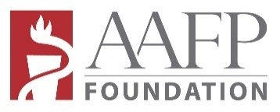
Family Medicine Philanthropic Consortium
2023 FMPC Grant Awards Budget Worksheet

INSTRUCTIONS:
● Complete and upload the budget worksheet with the application and attachments online.
● Completed application and attachments (budget and supporting documents) are due by 11:59 P.M. Central Time, February 28, 2023.
● Submitted application including attachments MUST NOT EXCEED 12 PAGES. Longer submissions will be disqualified.
● QUESTIONS? Contact Veronica Roberts at 913-906-6239 or email vroberts@aafp.org.

BUDGET
- TABLE OF ALL FUNDING SOURCES FOR THIS PROJECT

 | FMPC REQUEST | OTHER FUNDING | IN-KIND or NON-CASH** | TOTAL BUDGET BY CATEGORY
STAFF & ADMIN Include all staff and personnel, interns, consultants, volunteers, members, etc. | $ | $ | $ | $
SUPPLIES | $ | $ | $ | $
EQUIPMENT | $ | $ | $ | $
OTHER | $ | $ | $ | $
TOTAL per Funding Source | $ | $ | $ | Grand Total  $
*% of FMPC Staffing & Admin Cannot exceed 30%*  (*Calculate using FMPC Staff & Admin/Total FMPC Funding) | %

*For example, if total FMPC Request is $2,000, FMPC Staff & Admin cannot exceed $2,000 *.30=$600.

**In-kind or non-cash donations can be goods, services or labor of people assigned to accomplish the project.

BUDGET NARRATIVE (500 words or less): This section should be comprehensive and address funding requested from FMPC, as well as funding from other sources and in-kind support. For all categories, please explain the need for the cost and how costs were estimated.

