f
Content for Office Social Media Channels

Suggested Timing | Facebook Content | Twitter Content
Winter | Attention parents of teens! Did you know that millions of teens are under-vaccinated against serious infectious diseases like human papillomavirus (HPV) and meningococcal meningitis (MenACWY)? Now that the holiday hustle and bustle is over, please give us a call to see that your teen is up to date on his or her vaccinations, or visit our website to learn more [insert link to website]! | Schedules are slowing down after the holidays. Call us to see if your teen is up 2 date on at least 4 CDC-recommended vaccines. #vax4teens
Summer  (Back to school theme) | You want only the best for your teen, especially when it comes to his or her health. Before school starts, give us a call to see that they are up to date on their vaccinations. The CDC recommends at least four vaccines to help protect against serious infectious diseases. You can also learn more at our website [insert link]. #vax4teens | #DYK teens are at higher risk of certain infectious diseases? Call to see that you’re up 2 date on vaccines before school. #vax4teens
Fall  (Flu season theme) | The Centers for Disease Control and Prevention (CDC) said that less than 50% of teenagers received the flu vaccine during the 2016-2017 flu season. And even less (39%) received the second dose of the meningitis (MenACWY) vaccine recommended at age 16. Millions of teens remain under-vaccinated, so we’re encouraging parents/guardians of teens to call or email us to see that your child is up to date. You can also learn more about vaccinations at our website [insert link]. | 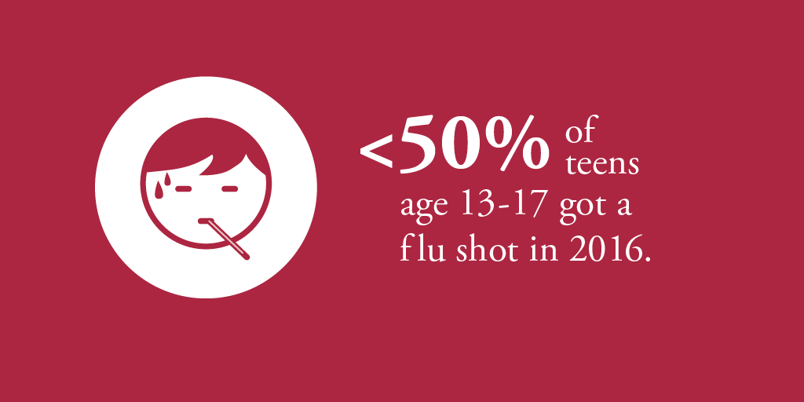  Teens, help protect yourself and call us about a flu shot today. #vax4teens

General (for use at any time) | Meningitis is a rare but potentially deadly disease and teens are at increased risk due to things they often do, such as sharing water bottles, living in dorms or kissing. Our office is committed to seeing that outbreaks of vaccine-preventable diseases don’t happen in our town. Please call us to make sure your teen is up to date on his or her immunizations. You can also learn more about vaccinations at our website [insert link]. | #DYK outbreaks of vaccine-preventable diseases may still occur? Call us to see if your teen is up 2 date on vaccines. #vax4teens
 | Parents of teens, we know how busy you and your teens are. Because teens are so active, it’s important to check on their health. This includes being up to date on their vaccinations. Please call us to check on your teen’s vaccination record and see if you need to make an appointment. You can learn more about at least 4 CDC-recommended vaccinations on our website [insert link]. | Are you up-to-date on vaccinations recommended for teens? Not sure? Call us to see that you’re on track today. #vax4teens
 | As your teens prepare for their next adventure, we want to help them stay healthy just as much as you do! Did you know that the CDC recommends a second dose of the meningitis (MenACWY) vaccine at age 16 to help protect them during the years they are at increased risk? The Childhood and Adolescent Immunization Schedule now features a specific 16-year-old immunization visit. This modification, as recommended by the CDC and the Advisory Committee on Immunization Practices (ACIP), highlights the importance of scheduling 16-year-olds for necessary vaccinations to help protect them against serious infectious diseases. To learn about at least four recommended vaccinations for your teen, give us a call today to see if you should schedule a checkup for your son or daughter. You can also learn more about vaccinations at our website [insert link]. | #DYK the CDC recommends a 2nd dose of the meningitis (MenACWY) vaccine at 16? Call us to learn more. #vax4teens
 | Human papillomavirus (HPV) can cause various cancers in both boys and girls. About 14 million people, including teens, become infected with HPV each year. The HPV vaccine is recommended for boys and girls at age 11 or 12. The vaccine is given as a multi-dose series. Teens need two doses if they received the first before age 15. Teens need three doses if they start the series at age 15 or later. Call us today to learn more about the HPV vaccine and other vaccinations that may help protect your teen. You can also learn more about vaccinations on our website [insert link] and more about the HPV vaccine from this CDC video. | #DYK only two HPV vaccinations are recommended if received at ages 11-14? Call us to learn more. #vax4teens

